* **Proposed Title**: ServeU
* **Field of Invention**
  + This invention is related to comprehensive and user-friendly web application that streamlines the process of discovering, booking, and managing essential services while providing access to verified and quality service providers like laundry, grocery shopping, and maid services in a particular area.
* **Background**
  + **Problem to be solved:**
    - Young professionals, particularly urban-dwelling bachelors, face significant challenges in efficiently accessing and managing essential daily services like laundry, grocery shopping, Mess Food services and maid services.
    - According to recent studies, approximately 70% of this demographic report wasting valuable time and experiencing subpar service quality in their quest for reliable providers.
    - There is not any online platform where user can compare prices and quality of the services. Due to this lot of people pay overprice service charge or experience bad service quality.
    - Lack of web application which streamlines the process of discovering, booking and managing essential services while providing access to verified and quality service provider within the local area.
* **Objective**
  + A primary object of the present invention is to provide a comprehensive and user-friendly web application that streamlines the process of discovering, booking, and managing essential services while providing access to verified and quality service providers.
  + Our aims to not only save users time and reduce stress but also enhance their overall quality of life.
  + Another object of the present invention is to provide a comprehensive platform where user can compare the prices and rating of different service providers and streamline all the things.
* **Figures**

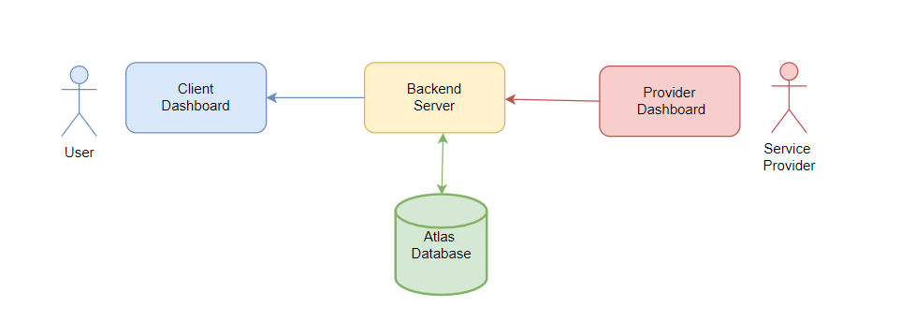

Figure 1.0

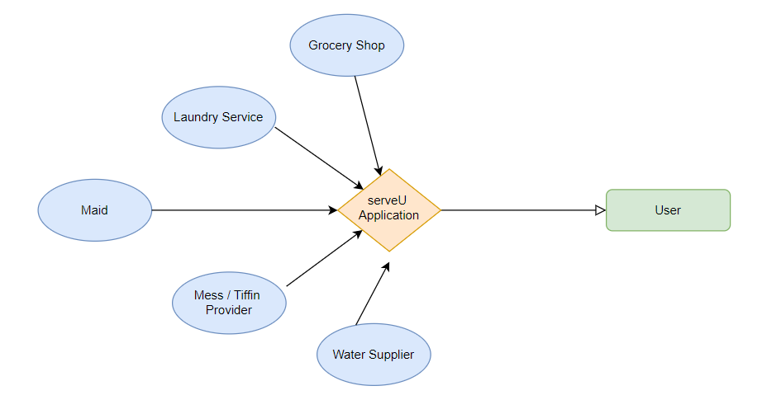

**Figure 2.0**

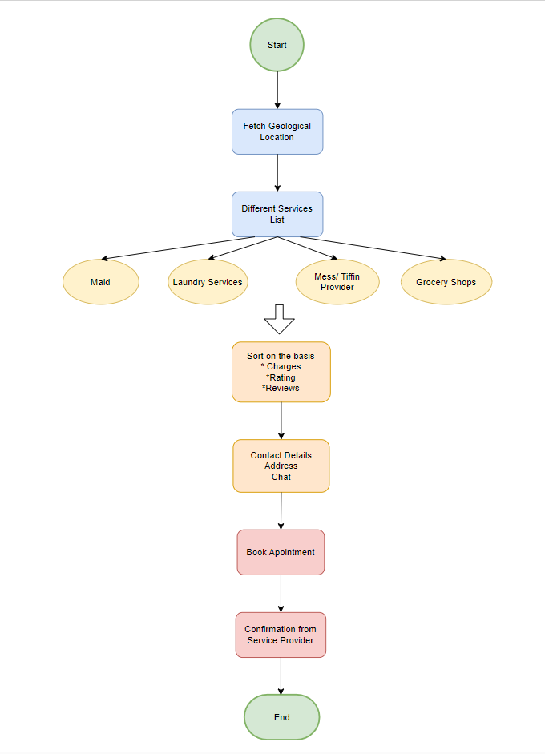

* **Claims (Novel/ Innovation Idea):**
  + **Provide direct Communication channel between user and service Provider:**

Unique feature of ServeU is its emphasis on facilitating direct communication between users and service providers through real-time chat and messaging functionality. This feature allows for seamless interaction, enabling users to communicate their needs, preferences, and inquiries directly to service providers. Likewise, service providers can promptly respond to user messages, address any concerns, and provide timely assistance. By prioritizing this direct communication channel, ServeU enhances the user experience, fosters transparency, and ensures efficient service delivery, setting it apart from other platforms in the market.

* + **Location service:**

Service provider location in the ServeU project lies in the utilization of geolocation technology to connect users with nearby service providers efficiently. This feature allows users to find service providers based on their current location, ensuring proximity and convenience. By integrating geolocation APIs, ServeU optimizes the user experience by offering services from providers in the same locality, enhancing accessibility and reducing response times. Additionally, this approach promotes local businesses and fosters community engagement by prioritizing service providers within the user's vicinity.

* **Apparatus/Technology used**
  + Frontend: React Library
  + Backend: ExpressJs, Nodejs
  + Database: MongoDB Atlas
  + Deployment: Hostinger
* **Abstract**
  + We are tackling a problem generally faced by a the new commers to any new place.
  + Our main target audience are the students and the bachelors who lives in paying guest rooms , they generally face problems in accessing and managing essential daily services like laundry, grocery shopping, Mess Food services and maid services at an affordable and effective rate .
  + So, providing solutions to it , we are developing a web application named as ServeU which will bring both the customer and vendor at same platform .
  + ServeU allows users to discover, book, and manage verified and quality service providers in their local area, while also enabling them to compare prices and service quality across different options.
  + ServeU leverages the latest technology, such as image analysis, to enhance the user experience and satisfaction. ServeU also offers features such as feedback and rating system, and loyalty rewards program.
  + ServeU is a novel and innovative web application that fills the gap in the existing market and addresses the needs and challenges of the target demographic.
  + This web app will be beneficial for both the vendor and customer as the customer will get multiple options to get the basic services and the vendor will get the job.
* **End users**
  + Bachelors, Student and newcomers who shifted to the city.
* **Advantages**
  + It saves time of the user to try new things again and again till he gets satisfied with the work of service provider.
  + user-friendly web application that streamlines the process of discovering, booking, and managing these essential services while providing access to verified and quality service providers.
* **Summary**
  + Young professionals, especially urban-dwelling bachelors, often encounter difficulties when it comes to accessing and managing essential daily services such as laundry, grocery shopping, and maid services.
  + Recent studies have shown that approximately 70% of this demographic waste valuable time and experience subpar service quality while searching for reliable providers.
  + To address these challenges, a comprehensive and user-friendly mobile application has been developed. This innovative web app aims to streamline the process of discovering, booking, and managing essential services while providing access to verified and quality service providers.
  + By utilizing this application, users can save time, reduce stress, and enhance their overall quality of life. The platform offers a range of features, including service listings, location services, price comparison, booking and scheduling, user reviews and ratings, and chat and messaging functionalities. With this app, young professionals can easily access essential services, compare prices, and make informed decisions, ultimately improving their daily lives.
* **Authors List**
  + Name: MD Faizal
  + Email: [faizalmohammad67@gmail.com](mailto:faizalmohammad67@gmail.com)
  + Sign: 
  + Name: Manish Kumar Mandavi
  + Email: [mandavimanish8143@gmail.com](mailto:mandavimanish8143@gmail.com)
  + Sign: 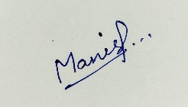
  + Name: Harsh Choudhary
  + Email: [hc123656@gmail.com](mailto:hc123656@gmail.com)
  + Sign: 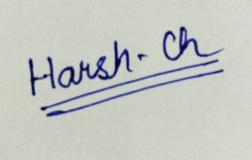
  + Name: Mr. Akash Goel
  + Email:
  + Sign: